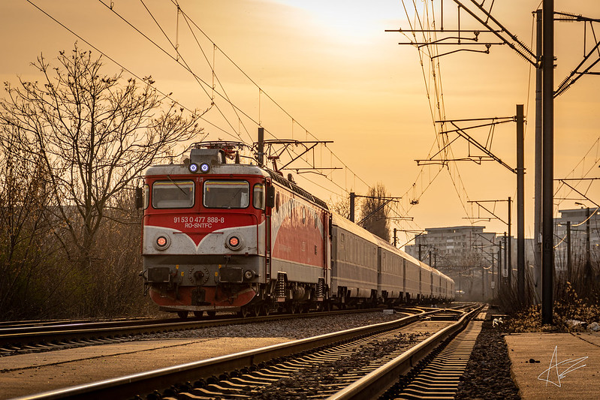Managing trains (pl/sql edition)

@Adrian Zărnoianu

This is the project from the first semester (the tables and inserts from the Database course) alongside new problems and the PL/SQL blocks and commands I added using the theory learned from the DBMS course that solve them.

The database I made follows the trains and their routes, and is made such that users (the database admin, dispatchers, operators and guests) could update it with reports about the trains, which include delay codes and explanations.

The reasons I chose this subject in the first semester are the high frequency of students (including me) who travel by train, and probably the frustration some of us have when the trains we travel by have long delays out of nowhere. This project couldn’t have been done without the help of one of my friends, who knows CFR employees and managed to explain to me the process behind the delay system.

Thus, this database is heavily inspired by Cronos (their site where they manage the trains’ status). However, it is simplified, so a part of the actual real-life problems may not be applied in this project.

# The database query (made with dbdiagram.io):

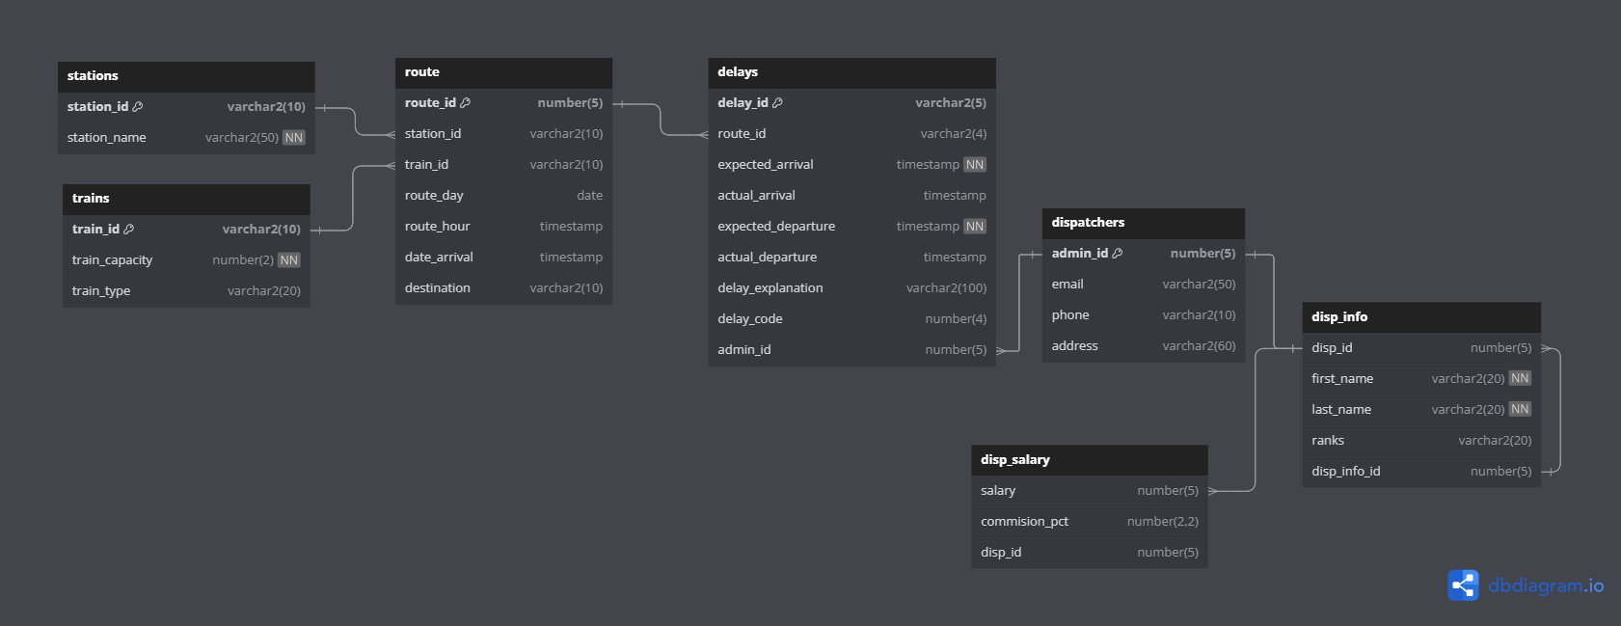

The tables have not been modified since the first semester. However, I have used another software this time to make the database diagram, now including also the 1:M/1:1 relationship.

The TRAIN table holds basic information about the trains that can be used for routes.

The STATIONS table has station details, so that in the ROUTE table, only registered stations can be used.

The ROUTE table has 3 foreign keys: the train_id, and two station_id’s, that represent the station the train leaves from and the station the train goes to. The train_id is used so that it can be identified in the DELAYS table which of the trains have delays.

The DELAYS table has information about which train, on which route and how much it delayed at departure and arrival. If the trains go out of order, or are cancelled they have special codes.

The DISPATCHERS, DISP_SALARY AND DISP_INFO tables have the users, their ranks, and the salaries they have. The DISP_INFO table has another field for the superiors of the users.

# ALTERNATIVE AND REPETITIVE STRUCTURES

--display the first 4 delay explanations(the delay ids in the table start from 10)

DECLARE

    V_DELAY_EXP DELAYS.DELAY_EXPLANATION%TYPE;

    I NUMBER:=10;

BEGIN

    WHILE I<14 LOOP

        SELECT DELAY_EXPLANATION INTO V_DELAY_EXP FROM DELAYS WHERE DELAY_ID = I;

        DBMS_OUTPUT.PUT_LINE(V_DELAY_EXP);

        I:= I+1;

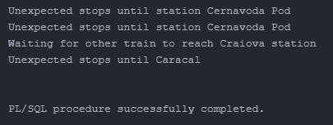    END LOOP;

END;

/

--update the train_capacity number to a train

--if there is no train like the input, write a message

DECLARE

    V_INPUT_TRAIN TRAINS.TRAIN_ID%TYPE := :TRAIN_ID;

BEGIN

    UPDATE TRAINS

    SET TRAIN_CAPACITY = 3

    WHERE TRAIN_ID = V_INPUT_TRAIN;

    IF SQL%NOTFOUND

        THEN DBMS_OUTPUT.PUT_LINE('THERE IS NO TRAIN WITH ID '|| V_INPUT_TRAIN);

    ELSE

        DBMS_OUTPUT.PUT_LINE('TRAIN UPDATED SUCCESFULLY.');

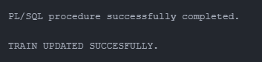    END IF;

END;

/

(for input R-E9213) 🡪

# DATa collections

The project makes use of varrays, nested tables and index by tables.

NOTE: most of the exercises combine more than two requirements, and I will point out whenever there is a smaller requirement within the PL/SQL blocks

--display (using a varray of records) all the trains and when they leave

DECLARE

    TYPE R_REC IS RECORD(

        TRAIN_ID ROUTE.TRAIN_ID%TYPE,

        ROUTE_HOUR ROUTE.ROUTE_HOUR%TYPE

    );

    TYPE T_ARRAY IS VARRAY(30) OF R_REC;

    V T_ARRAY;

    I PLS_INTEGER;

BEGIN

    SELECT TRAIN_ID, ROUTE_HOUR BULK COLLECT INTO V

    FROM ROUTE;

    FOR I IN V.FIRST..V.LAST LOOP

        DBMS_OUTPUT.PUT_LINE('TRAIN ' || V(I).TRAIN_ID|| ' LEAVES AT: '||V(I).ROUTE_HOUR);

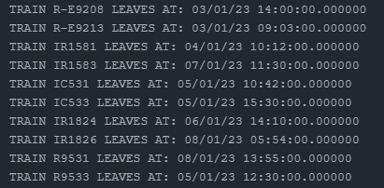    END LOOP;

END;

/

FOR loop, using the I variable

Note: this was part of an exercise which used a procedure, the procedure definition will appear later in this project \/

-- create a procedure, which takes the dispatcher id as a parameter and displays their salary status

-- if the salary is <=5000 the salary is low, if the salary is<=9000, the status is medium, else is high

-- in the anonymous block, call the procedure for a specific id. if it doesn't exist, then raise the proper exception (input is 41172) (the program uses a record)

DECLARE

    V_DISP_ID DISP_SALARY.DISP_ID%TYPE := &DISP_ID;

    TYPE R_INFO IS RECORD(

        FIRST_NAME DISP_INFO.FIRST_NAME%TYPE,

        LAST_NAME DISP_INFO.LAST_NAME%TYPE

    );

    T R_INFO;

BEGIN

    SELECT FIRST_NAME, LAST_NAME INTO T FROM DISP_INFO

    WHERE DISP_ID = V_DISP_ID;

    DBMS_OUTPUT.PUT_LINE('DISPATCHER '||T.FIRST_NAME||' '||T.LAST_NAME||' (WITH ID '||V_DISP_ID||')''S STATUS:');

    SHOW_SALARY_STATS(V_DISP_ID);

EXCEPTION

  WHEN NO_DATA_FOUND THEN

  DBMS_OUTPUT.PUT_LINE('THIS DISPATCHER DOES NOT EXIST.');

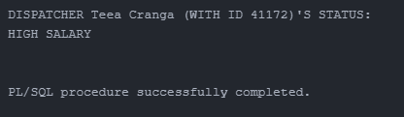END;

/

Implicit exception added here

# Exception handling

--select the trains which leave from a certain station(in this case bucu-n)

--if there are more than two, raise an exception

--if the station doesn't exist/no train leaves from there, raise NO_DATA_FOUND exception

DECLARE

    V_TRAIN NUMBER;

BEGIN

    SELECT TRAIN_ID INTO V_TRAIN FROM ROUTE WHERE STATION_ID='BUCU-N';

    --SELECT TRAIN_ID INTO V_TRAIN FROM ROUTE WHERE STATION_ID='IASI'; --for no_data_found

    EXCEPTION

        WHEN TOO_MANY_ROWS THEN

        DBMS_OUTPUT.PUT_LINE('THERE ARE MORE THAN TWO TRAINS WHICH LEAVE FROM BUCU-N');

        WHEN NO_DATA_FOUND THEN

        DBMS_OUTPUT.PUT_LINE('NO TRAIN LEAVES FROM THIS STATION');

END;

/

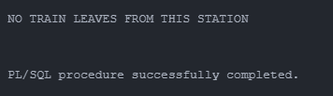

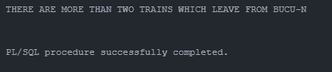this happens when I use

the second select 🡪

this happens when

I use the first select 🡪

NOTE: The following exclusive exception is from a procedure, so I won’t include the procedure later

--make a procedure which shows the email of a certain dispatcher using the id. if the id doesn't exist, raise an exception

CREATE OR REPLACE PROCEDURE GET_DISP_DATA(P_DISP_ID DISPATCHERS.ADMIN_ID%TYPE) IS

    CURSOR CUR IS SELECT FIRST_NAME, LAST_NAME, EMAIL, PHONE FROM DISPATCHERS D

    JOIN DISP_INFO I ON ADMIN_ID = DISP_ID

    WHERE ADMIN_ID = P_DISP_ID;

    R CUR%ROWTYPE;

    EXCEP EXCEPTION;

    PRAGMA EXCEPTION_INIT(EXCEP,-20000);

BEGIN

    OPEN CUR;

    FETCH CUR INTO R;

    IF CUR%NOTFOUND THEN RAISE EXCEP;

    END IF;

    DBMS_OUTPUT.PUT_LINE(R.FIRST_NAME||' '||R.LAST_NAME||'''S DETAILS: '||R.EMAIL||' '||R.PHONE);

CLOSE CUR;

EXCEPTION

WHEN EXCEP THEN

    DBMS_OUTPUT.PUT_LINE('DISPATCHER NOT FOUND');

END;

/

BEGIN

--GET_DISP_DATA(10003534534532); --this will raise the exception

GET_DISP_DATA(41172);

END;

/

If I use the first call of the procedure, it will raise the exception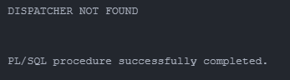

Otherwise, it will show the details as in the image below:

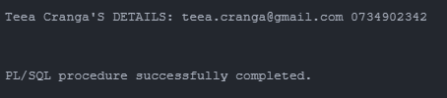

# cursor management

--make an explicit cursor which explains all the data in the trains table

DECLARE

    CURSOR CUR_TRAINS IS

    SELECT TRAIN_TYPE, TRAIN_ID, TRAIN_CAPACITY

    FROM TRAINS;

BEGIN

    FOR V_TRAIN_RECORD IN CUR_TRAINS LOOP

        DBMS_OUTPUT.PUT_LINE('THE ' || V_TRAIN_RECORD.TRAIN_TYPE ||' TRAIN, WITH ID: ' || V_TRAIN_RECORD.TRAIN_ID || ' HAS A NUMBER OF ' || V_TRAIN_RECORD.TRAIN_CAPACITY || ' COACHES.');

    END LOOP;

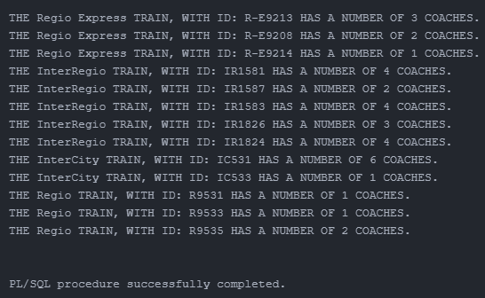END;

/

--create an explicit cursor which takes the user_ids of those who reported delays on a specific train (use a parameter)

--input is 1502 in the pl/sql block

DECLARE

    CURSOR CUR(P_ROUTE_ID DELAYS.ROUTE_ID%TYPE) IS

    SELECT ADMIN_ID FROM DELAYS

    WHERE ROUTE_ID = P_ROUTE_ID;

    R CUR%ROWTYPE;

BEGIN

    OPEN CUR(1502);

    LOOP

        FETCH CUR INTO R;

        EXIT WHEN CUR%NOTFOUND;

        DBMS_OUTPUT.PUT_LINE('USER: '||R.ADMIN_ID||' REPORTED ON THIS ROUTE');

    END LOOP;

    CLOSE CUR;

END;

/

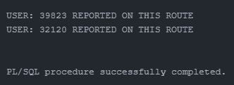

# functions, procedures, packages

--create a procedure which displays the train and how many minutes of delay it had at both arrival and departure

--if the train has no delay at either of the actions, replace with -1

CREATE OR REPLACE PROCEDURE DELAYS_TRAIN(P_TRAIN_ID ROUTE.TRAIN_ID%TYPE) IS

    CURSOR CUR IS SELECT R.TRAIN_ID, R.ROUTE_ID, NVL(ABS(EXTRACT(MINUTE FROM D.ACTUAL_ARRIVAL-D.EXPECTED_ARRIVAL)),-1) ARRIVAL,

    NVL(ABS(EXTRACT(MINUTE FROM D.ACTUAL_DEPARTURE-D.EXPECTED_DEPARTURE)),-1) DEPARTURE

    FROM DELAYS D, ROUTE R

    WHERE D.ROUTE_ID=R.ROUTE_ID

    AND R.TRAIN_ID = P_TRAIN_ID

    ORDER BY R.TRAIN_ID;

    R CUR%ROWTYPE;

BEGIN

    OPEN CUR;

    FETCH CUR INTO R;

    DBMS_OUTPUT.PUT_LINE('MINUTES OF DELAY AT ARRIVAL: '|| R.ARRIVAL||CHR(10)||'MINUTES OF DELAY AT DEPARTURE: '||R.DEPARTURE);

END;

/

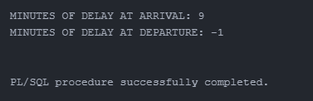BEGIN

    DELAYS_TRAIN('IR1583');

END;

/

NOTE: the procedure call block and its output are above, at the exception chapter

-- create a procedure, which takes the dispatcher id as a parameter and displays their salary status

-- if the salary is <=5000 the salary is low, if the salary is<=9000, the status is medium, else is high

-- in the anonymous block, call the procedure for a specific id. if it doesn't exist, then raise the proper exception (input is 41172)

CREATE OR REPLACE PROCEDURE SHOW_SALARY_STATS(P_DISP_ID DISP_SALARY.SALARY%TYPE) IS

V_SALARY NUMBER;

BEGIN

    SELECT SALARY INTO V_SALARY

    FROM DISP_SALARY

    WHERE DISP_ID=P_DISP_ID; CASE used

    CASE

    WHEN V_SALARY<=5000 THEN

        DBMS_OUTPUT.PUT_LINE('LOW SALARY');

    WHEN V_SALARY<=9000 THEN

        DBMS_OUTPUT.PUT_LINE('MEDIUM SALARY');

    ELSE

        DBMS_OUTPUT.PUT_LINE('HIGH SALARY');

    END CASE;

END;

/

-- create a function which returns true/false depending on the status of that train

--(if the train has the delay code 1003/1004, it's cancelled/broken, else, it will reach the final station soon)

--create a table of records to store the delays and the routes which they belong to and show how many trains were cancelled/broken during their rides

CREATE OR REPLACE FUNCTION IS_CANCELLED_OR_BROKEN(P_DELAY_ID DELAYS.DELAY_ID%TYPE) RETURN BOOLEAN IS

V_DELAY DELAYS.DELAY_CODE%TYPE;

BEGIN

    SELECT DELAY_CODE

    INTO V_DELAY nested table, with index by

    FROM DELAYS

    WHERE DELAY_ID = P_DELAY_ID;

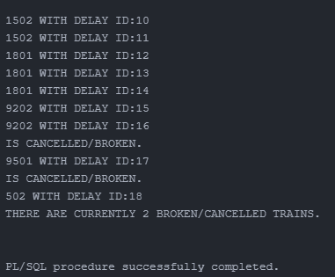    IF V_DELAY IN(1003,1004) THEN

        RETURN TRUE;

    ELSE RETURN FALSE;

    END IF;

END;

/

DECLARE

    TYPE RECORD_TRAINS IS RECORD(

        R_ROUTE_ID DELAYS.ROUTE_ID%TYPE,

        R_DELAY_ID DELAYS.ROUTE_ID%TYPE

    );

    TYPE T_NAME IS TABLE OF RECORD_TRAINS INDEX BY PLS_INTEGER;

    V T_NAME;

    I PLS_INTEGER;

    V_NUMBER_CANCELLED_BROKEN NUMBER := 0;

BEGIN

    SELECT ROUTE_ID, DELAY_ID BULK COLLECT INTO V

    FROM DELAYS;

    FOR I IN V.FIRST .. V.LAST LOOP

        DBMS_OUTPUT.PUT_LINE(V(I).R_ROUTE_ID||' WITH DELAY ID:'||V(I).R_DELAY_ID);

        IF IS_CANCELLED_OR_BROKEN(V(I).R_DELAY_ID) THEN

            DBMS_OUTPUT.PUT_LINE('IS CANCELLED/BROKEN.');

            V_NUMBER_CANCELLED_BROKEN:=V_NUMBER_CANCELLED_BROKEN+1;

        END IF;

    END LOOP;

    DBMS_OUTPUT.PUT_LINE('THERE ARE CURRENTLY '||V_NUMBER_CANCELLED_BROKEN||' BROKEN/CANCELLED TRAINS.');

END;

/

--create two functions: one of them returns the station name the train leaves from and one which returns the name of the station in which it arrives to.

--use them in a plsql block

CREATE OR REPLACE FUNCTION GET_STATION_NAME(P_ROUTE_ID IN ROUTE.ROUTE_ID%TYPE) RETURN VARCHAR2 IS

    P_STATION_NAME STATIONS.STATION_NAME%TYPE;

BEGIN

    SELECT STATION_NAME INTO P_STATION_NAME FROM STATIONS

    WHERE STATION_ID = (SELECT STATION_ID FROM ROUTE WHERE ROUTE_ID = P_ROUTE_ID);

    RETURN P_STATION_NAME;

END;

/

BEGIN

    DBMS_OUTPUT.PUT_LINE(GET_STATION_NAME(9201));

END;

/

CREATE OR REPLACE FUNCTION GET_DEST_NAME(P_ROUTE_ID IN ROUTE.ROUTE_ID%TYPE) RETURN VARCHAR2 IS

    P_STATION_NAME STATIONS.STATION_NAME%TYPE;

BEGIN

    SELECT STATION_NAME INTO P_STATION_NAME FROM STATIONS

    WHERE STATION_ID = (SELECT DESTINATION FROM ROUTE WHERE ROUTE_ID = P_ROUTE_ID);

    RETURN P_STATION_NAME;

END;

/

BEGIN

    DBMS_OUTPUT.PUT_LINE('TRAIN 9201 HAS ROUTE: '||GET_STATION_NAME(9201)||'-'||GET_DEST_NAME(9201));

END;

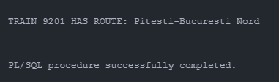/

## THE PACKAGe definition

--create a package

CREATE OR REPLACE PACKAGE PACK_UTILS AS

    --gets the full name of the dispatcher

    FUNCTION GET_FULL_NAME(P_DISP_ID IN DISP_INFO.DISP_ID%TYPE) RETURN VARCHAR2;

    --gets the main superior of the user

    FUNCTION GET_SUPERIOR(P_DISP_ID IN DISP_INFO.DISP_ID%TYPE) RETURN VARCHAR2;

    --prints the rank of the user

    PROCEDURE PRINT_RANK(P_DISP_ID DISP_INFO.DISP_ID%TYPE);

END;

/

CREATE OR REPLACE PACKAGE BODY PACK_UTILS AS

    FUNCTION GET_FULL_NAME(P_DISP_ID IN DISP_INFO.DISP_ID%TYPE) RETURN VARCHAR2 IS

        V_FULL_NAME VARCHAR2(200);

        V_FIRST_NAME VARCHAR2(100);

        V_LAST_NAME VARCHAR2(100);

    BEGIN

        SELECT FIRST_NAME, LAST_NAME

        INTO V_FIRST_NAME, V_LAST_NAME

        FROM DISP_INFO

        WHERE DISP_ID = P_DISP_ID;

        V_FULL_NAME := V_FIRST_NAME||' '||V_LAST_NAME;

        RETURN V_FULL_NAME;

    END GET_FULL_NAME;

    FUNCTION GET_SUPERIOR(P_DISP_ID IN DISP_INFO.DISP_ID%TYPE) RETURN VARCHAR2 IS

        V_SUPERIOR_ID DISP_INFO.DISP_ID%TYPE;

        V_FIRST_NAME VARCHAR2(100);

        V_LAST_NAME VARCHAR2(100);

        V_FULL_INFO VARCHAR2(200);

    BEGIN

        SELECT DISP_INFO_ID

        INTO V_SUPERIOR_ID

        FROM DISP_INFO

        WHERE DISP_ID = P_DISP_ID;

        SELECT FIRST_NAME, LAST_NAME

        INTO V_FIRST_NAME, V_LAST_NAME

        FROM DISP_INFO

        WHERE DISP_ID=V_SUPERIOR_ID;

        V_FULL_INFO := ' WITH SUPERIOR: '|| V_SUPERIOR_ID||' '||V_FIRST_NAME||' '||V_LAST_NAME;

        RETURN V_FULL_INFO;

        EXCEPTION

            WHEN NO_DATA_FOUND THEN

            RETURN 'THE USER IS THE ADMIN.';

    END GET_SUPERIOR;

    PROCEDURE PRINT_RANK(P_DISP_ID DISP_INFO.DISP_ID%TYPE) IS

        V_RANKS VARCHAR2(20);

    BEGIN

        SELECT RANKS INTO V_RANKS FROM DISP_INFO

        WHERE DISP_ID = P_DISP_ID;

        DBMS_OUTPUT.PUT_LINE('THE USER''S RANK IS: '|| V_RANKS);

    END PRINT_RANK;

END;

/

--show all the users, their ranks and their superiors

DECLARE

    FULL_NAME VARCHAR2(200);

    SUP_NAME VARCHAR2(200);

BEGIN

    SELECT

    PACK_UTILS.GET_FULL_NAME(DISP_ID),

    PACK_UTILS.GET_SUPERIOR(DISP_ID) INTO FULL_NAME, SUP_NAME

    FROM DISP_INFO

    WHERE DISP_ID = 21031;

    DBMS_OUTPUT.PUT_LINE(FULL_NAME|| ' '||SUP_NAME);

    PACK_UTILS.PRINT_RANK(21031);

END;

/

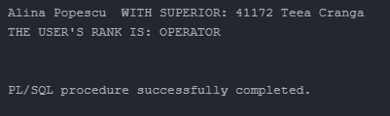

--create a trigger to prevent modifying the salary of guests

--they have the commission pct of 0.1

CREATE OR REPLACE TRIGGER CH_SALARY_GUESTS AFTER UPDATE OF SALARY ON DISP_SALARY FOR EACH ROW

BEGIN

    IF :NEW.SALARY<>:OLD.SALARY AND :NEW.COMMISSION_PCT = 0.1 THEN

    RAISE_APPLICATION_ERROR(-20001,'WE CAN''T CHANGE THE SALARY');

   END IF;

END;

/

BEGIN

    UPDATE DISP_SALARY SET SALARY = 3400 WHERE COMMISSION_PCT=0.1;

END;

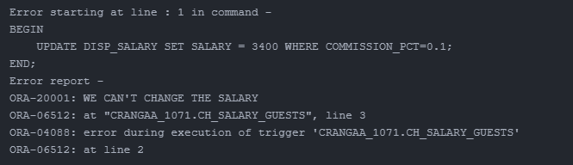/

--create a trigger which prevents adding trains with more thean 10 coaches or less or equal to 0

CREATE OR REPLACE TRIGGER CH_TRAIN_COACHES BEFORE INSERT ON TRAINS FOR EACH ROW

BEGIN

    IF :NEW.TRAIN_CAPACITY < 0 OR :NEW.TRAIN_CAPACITY > 10 THEN

        DBMS_OUTPUT.PUT_LINE('THE TRAIN HAS AN INVALID TRAIN CAPACITY.');

    END IF;

END;

/

BEGIN

    INSERT INTO TRAINS VALUES('R10310', 11, 'Regio Express');

END;

/

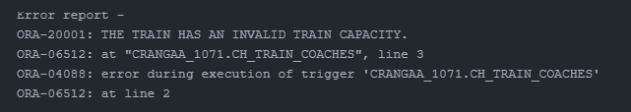

--create a trigger which prevents adding duplicate dispatchers in the disp_info table

CREATE OR REPLACE TRIGGER DUP_USER AFTER INSERT OR UPDATE ON DISP_INFO

DECLARE

    V_DUPLICATES NUMBER;

BEGIN

    SELECT COUNT(*) INTO V_DUPLICATES FROM DISP_INFO

    WHERE PACK_UTILS.GET_FULL_NAME(DISP_ID) IN

    (SELECT PACK_UTILS.GET_FULL_NAME(DISP_ID) AS "FULL NAME"

     FROM DISP_INFO

     GROUP BY PACK_UTILS.GET_FULL_NAME(DISP_ID)

     HAVING COUNT(*) > 1

    );

   IF V_DUPLICATES > 0 THEN

      RAISE_APPLICATION_ERROR(-20001, 'DUPLICATE DISPATCHER NAME FOUND!');

   END IF;

END;

/

BEGIN

    INSERT INTO DISPATCHERS VALUES('23423', 'ABC@GMAIL.COM', '03243242','ASDASDAS');

    INSERT INTO DISP_INFO VALUES('23423','OPERATOR','21031', 'Alina','Vlaicu');

END;

/

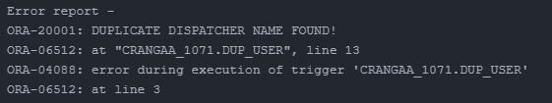

--create a trigger which prevents modifying delays

CREATE OR REPLACE TRIGGER INS_SAME_STATION AFTER INSERT OR UPDATE ON ROUTE

DECLARE

    CURSOR CUR IS SELECT STATION_ID, DESTINATION

    FROM ROUTE;

    R CUR%ROWTYPE;

BEGIN

    OPEN CUR;

    LOOP

        FETCH CUR INTO R;

        EXIT WHEN CUR%NOTFOUND;

        IF R.STATION_ID = R.DESTINATION THEN

            RAISE_APPLICATION_ERROR(-20001,'THE TRAIN CANNOT GO TO THE SAME STATION WHERE IT DEPARTS FROM.');

        END IF;

    END LOOP;

    CLOSE CUR;

END;

/

BEGIN

    INSERT INTO ROUTE VALUES(9203,'PITE','R-E9208', TO_DATE('05-01-2023','dd-mm-yyyy'),TO_TIMESTAMP('05-01-2023 10:42','dd-mm-yyyy hh24:mi'),TO_TIMESTAMP('05-01-2023 12:34','dd-mm-yyyy hh24:mi'),'PITE');

END;

/

